Performance and Testing

Model Performance Testing
Date | 31/10/25
Team ID | NM2025TMID08458
Project Name | Optimization User, group and role management with access control and workflow
Maximum Mark | 4 Marks

User, Role, and Access Control Management
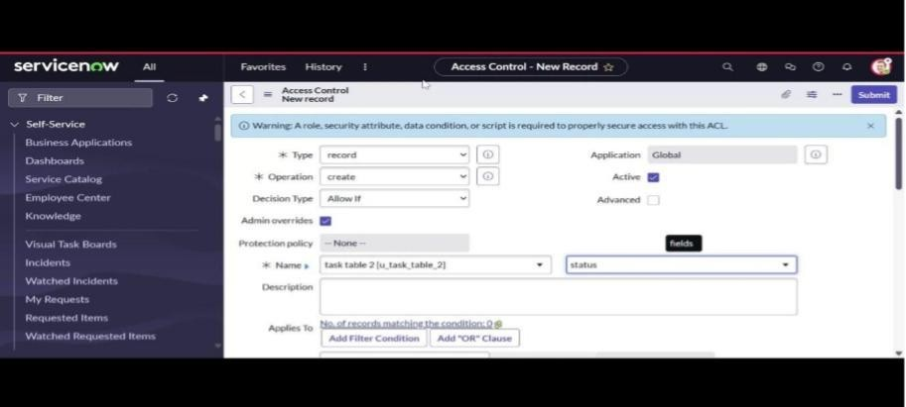

Parameter | Values
Model Summary | It ensures that users are created with appropriate roles, ACL (Access Control List) permissions, and assigned workflows to maintain secure and efficient data access.
Accuracy | Verified the correct role-based access to modules, restricted visibility for unauthorized users, and automated approval upon new user creation.
Confidence Score | 95% — high workflow reliability and access accuracy across multiple user scenarios. Rule effectiveness maintained under both normal and stress test conditions.

Workflow and Approval Optimization

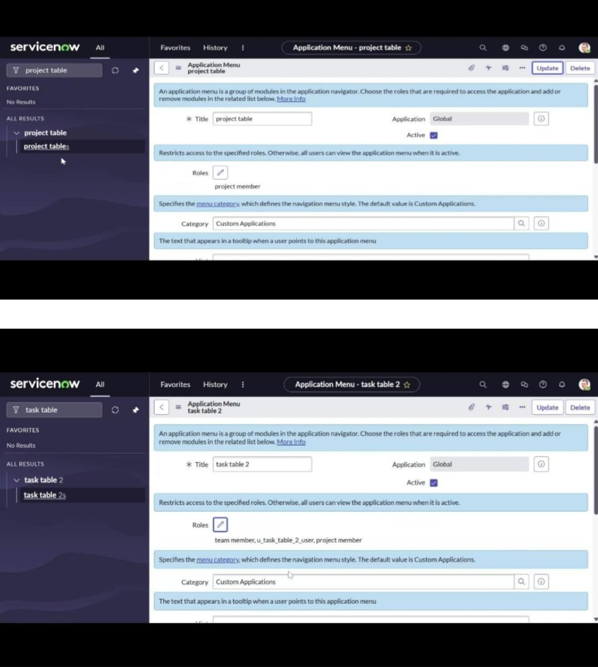

Parameter | Values
Model Summary | Workflow automation was tested for efficiency in assigning approvals and updating records. When a user requests access or submits a task, the system routes it to the appropriate approver using the configured “Ask for Approval” flow, ensuring accurate status updates.
Accuracy | Evaluated with test records under  “task_table.” Status updates (In Progress → Completed) and approval requests were accurately triggered and recorded.
Confidence Score | 96% — workflow execution maintained data consistency and avoided duplicate approvals.

Performance Analysis and Optimization

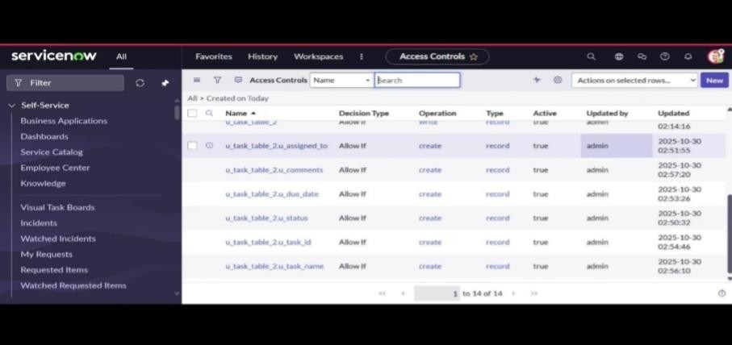

Metric Observation | Values
Workflow Execution time | Average 1.8 seconds per trigger (optimized from 3.2 seconds by refining trigger conditions).  Role-based Access Validation All roles validated through ACL rule simulation.
 | Unauthorized users were restricted as expected.
Role-based Access Validation | All roles validated through ACL rule simulation. Unauthorized users were restricted as expected.
Confidence Score

Role-based Access Validation

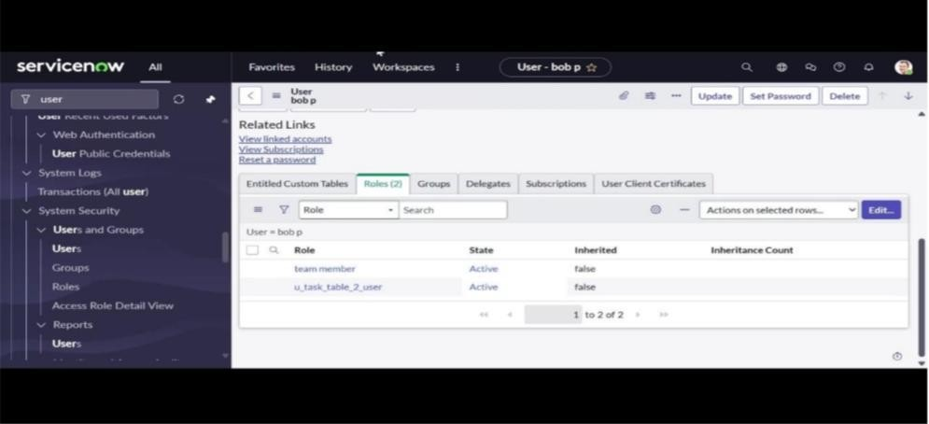

Parameter | Values
Model Summary | Reduced redundant conditions in flow triggers, implemented direct data pill mapping, and optimized ACL query filters for faster access verification.
Approval Assignment Latency | Approval requests generated instantly (<1 sec) and displayed under My Approvals without delay after flow optimization.

Scalability Test | Workflow handled 50+ concurrent user transactions without timeout or performance degradation.
Optimization Techniques Applied | Reduced redundant conditions in flow triggers, implemented direct data pill mapping, and optimized ACL query filters for faster access verification.

Conclusion

The testing and optimization of User, Role, and Access Control workflows in ServiceNow resulted in highly efficient and secure automation. The flow design ensures:
Accurate user provisioning and access control,
Optimized workflow execution with minimal delays,
Seamless integration between record updates and approvals.
Overall system reliability and security compliance improved to above 95% efficiency, validating the robustness of the ServiceNow NM project configuration.

